**Program from softcopy: c-5**

1. **Illustration of simple (if) statement**
2. **Use of (if) for counting**
3. **Use of (if-else) to find the larger one**
4. **Selecting the largest of three numbers(if-else)**

**No:1 || Program: A program about illustration of simple (if) statement**

**Source code:**

**main( )**

**{**

**int a,b,c,d;**

**float ratio;**

**printf("enter four integer values\n");**

**scanf("%d %d %d %d",&a,&b,&c,&d);**

**if(c-d !=0)**

**{**

**ratio=(float)(a+b)/(float)(c-d);**

**printf("ratio=%f\n",ratio);**

**}**

**}**

**Sample Input :**



**Sample output:**

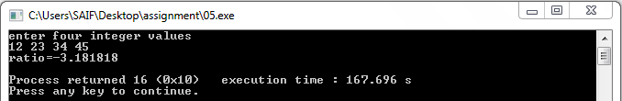

**No :2 || program :A program about Using of (if) for counting**

**Source code**:

//use of if for counting...

main()

{

int count, i;

float weight, height;

count = 0;

printf("Enter weight and height for 10 boys\n");

for (i =1; i <= 10; i++)

{

scanf("%f %f", &weight, &height);

if (weight < 50 && height > 170)

count = count + 1;

}

printf("Number of boys with weight < 50 kgs\n");

printf("and height > 170 cm = %d\n", count);

}

**Sample Input :**

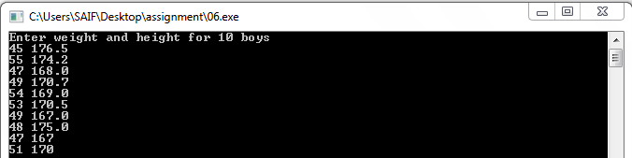

**Sample output:**

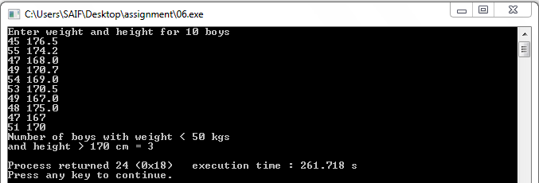

**No:3 || Program**: **A program about Using of (if-else) to find the larger one**

**Source code:**

//find the larger one...

main()

{

int val1;

int val2;

int larger;

printf("Enter two integers:");

scanf("%d %d" ,&val1,& val2);

if(val1>val2)

larger=val1;

else

larger=val2;

printf("larger of inputs is:%d\n",larger);

}

**Sample input**:



**Sample output**:

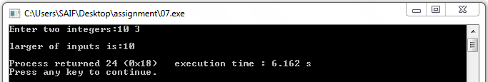

**No:4 || Program**: **A program about selecting the largest of three numbers(if-else )**

**Source code**:

//selecting the largest of three numbers...

main()

{

float A,B,C;

printf("enter three values:\n");

scanf("%f %f %f",&A,&B,&C);

printf("\nLargest value is :");

if(A>B)

{

if(A>C)

printf("%f\n",A);

else

printf("%f\n",C);

}

else

{

if(C>B)

printf("%f\n",C);

else

printf("%f\n",B);

}

}

**Sample input**:



**Sample output**:

